

Queen Eleanor’s CofE Junior School

Writing at Home
A Guide For Parents

How can I help with writing at home?

The basis of all good writing is good talk. Writing depends on knowing lots of words and being able to join them together in interesting ways.

- Provide a place for your child to write. The area should be an area that is quiet and well lit. Stock the "writing centre" with supplies such as paper, pencils and crayons. You can also gather family photos and magazines in the centre that can be used as story starters.
- Have an exciting selection of writing materials available e.g. a range of pencils, pens, coloured crayons, writing icing and writing soaps for bath time.
- Read, read, read! The best activity to improve writing is reading. If your child reads good books, they will be a better writer. Reading exposes children to general vocabulary, word study and content-specific vocabulary. Through reading, children see a variety of authors' techniques that they can use in their own writing.
- Encourage your child to keep a reflective journal at special times such as holidays or during difficult periods in their lives. This is excellent writing practice, as well as a good outlet for venting feelings. Encourage your child to write about things that happen at home and school. This reflective journal can be used to develop the "senses" of writing. Have your child write about what he saw, heard or felt on a trip or adventure. Provide experiences in your community that will interest your child and spark her writing. Especially encourage your child to write about personal feelings — pleasures as well as disappointments. When reading your child's journal (only if your child invites you to, of course), share your own feelings and ideas paired with positive feedback about your child's writing.
- Provide authentic writing opportunities for your child. Have your child write his own thank-you notes, party invitations and letters to family. Let your child make the grocery list. Finding a pen pal for your child would make writing "real." Helping children make the connection between writing and the "real" world will increase an interest in writing.
- Be a writing role model. Make sure your child sees you as a writer. Point out times that you use writing to communicate with others. Discuss authentic writing in the community such as articles and letters in the newspaper, on billboards or in written advertisements. Discuss the purpose of the writing and the target audience. When your child writes, you should write. You can schedule a day of the week that you will turn off the television and share your writing.
- Praise your child for trying and don’t dwell on mistakes. Focus on content and enjoyment of writing for fun and for purpose.

How can I help with Creative Writing?

Creative Writing Homework encourages children to use the skills they have learnt in class, this could be punctuation, grammar or the style of writing. Discussing the task is always a great start. It is common for children to find the ideas the hardest part of this homework. Often giving them a starting point or idea will get them interested in what they are doing. Making the work fun is important. Discuss what could be written together – create a short plan or simple plot it out together, then allow your child time to write it independently. What they produce does not have to be perfect or finished. Many children spend far too long striving for perfection – it is about quality not quantity. Your child’s teacher knows what they can produce in the time they are given and knows what to expect. Your child should also be aware of what is expected of them from their time working in class. Encourage your child to read through what they have written to check it all makes sense, and that they have not made unnecessary spelling errors. Often reading it aloud, will make a huge difference to the quality of your child’s writing. When they are finished, praise them for their hard work and point out the parts that you liked the best. If there is something you think they need to improve, point this out and work together to improve it, but don’t exceed the time limit given by the teacher.

There are many ways to help with writing and each child is working at a different stage throughout their time at QE. Here are some helpful tips, whatever level or ability your child is working at:

Less Confident Writers
- Encourage children to look at print on road signs, food packets, in books, magazines and catalogues.
- Go to the library and read favourite books over and over again. Enjoy them.
- Try fun activities that strengthen your child’s hand e.g. cutting, painting, squeezing playdough, picking up small things with tweezers and pegs.
- Use magnetic letters and make small words together. Leave a message on the fridge door and encourage your child to reply.
- Make up a story together about one of their toys. You write the story as they say the words. Make up a little booklet.
- Take photos and use the pictures in the book.
- Buy stickers of a favourite TV programme or book. Make your own little book about it.
- Let your child write their own Christmas cards, thank you letters, cards or emails to friends or relatives, invitations to a party, or a list of things they need to take on holiday.
- Cut up letters from magazines for children to make their names and short sentences.
- Make handwriting interesting – practise drawing letters in sand, water, or paint, use whiteboards, playdough, pastry or shaving foam.

More Confident Writers
- Continue talking about experiences. This remains the key to good writing. Talk about what has been seen, heard, smelled, tasted and touched with as many details as possible.
- Play word-building games to develop descriptive vocabulary such as Boggle, Scrabble, Guess Who, ‘What am I?’ (one person thinks of something to describe. They give clues by describing it, without saying its name. Other players have to guess what it is with as few clues as possible.)
- Create silly sentences or tongue twisters using alliteration (a group of words that all begin with the same sound) e.g. Sad Sid slipped on Sam’s salad sandwich. Encourage your child to rehearse their sentence out loud before they write it down. Also encourage children to punctuate their sentences with a full-stop and capital letter.
- Celebrate what the writing says first of all rather than focusing on errors. If a tricky word has been used in an interesting way, this should be praised even if it is spelled wrongly. Remember, it is difficult to get everything right when you are learning!
- Let children write part of shopping lists and then let them be responsible for carrying the list and finding certain items.
- After making a cake, doing a craft activity or playing a game, challenge children to write instructions for someone else to follow.
- Make up fun ways to remember how to spell difficult words e.g. Big Elephants Can Always Understand Small Elephants = because, what has a hat, when has a hen. Play ‘I Spy’ and ‘Hangman’ which encourage use of sounds and spellings.
- Encourage your child to learn weekly spellings and phonic group spellings. Write the spelling in sentences with accurate punctuation and practise high frequency words and handwriting.
- Also ensure your child completes homework on time, take an interest in what they are doing, and praise effort.

Confident Writers
- Help your child write a letter to their favourite author. Details can be found on the internet.
- As with early writers be aware of occasions when children can be involved in writing – shopping lists, cards, phone messages, notes to friends, invitations to family occasions, emailing friends, blogging, texting (be aware of e-safety).
- Write information pages or booklets about a hobby or something they find interesting e.g. dinosaurs, class topics, sports stars etc. Illustrate and label. Encourage use of paragraphs for blocks of information. Write postcards from holidays and record holiday events in a diary that can be shared with friends or family.
- Provide your child with a comfortable place to work and exciting writing materials. A dictionary or spell check on a computer would also be useful.
- Let your child see you being a model writer but also let them see that you are not perfect! Checking, making changes and editing what you write are a natural part of writing.
- After your child has produced written homework ask them to proof read their work for accuracy. After they have done this, have a look at the piece yourself. Ask your child what his/her writing targets are from time to time and help them work specifically on these.
- Read books to, and with, them that are at a higher level than their own reading to expose them to ambitious vocabulary and complex sentence structure.

Encouraging Reluctant Writers

If your child has barriers towards writing, or low self-esteem as a writer, praising and valuing your child’s writing is very important. Your child may need support when they write and may need you to talk through their ideas first and help with composing and structure. All children may need help with ideas to write-give them a starting point or a character/setting when story writing and challenge them to come up with an idea around this. Often it’s not having an idea which is daunting – or looking at a blank page. Making the page smaller or setting a target point can help as well.

Help your child go over problem spellings. It is extremely frustrating for children to have to battle with spelling and handwriting when they want to get their ideas down on paper. Knowing high frequency spellings will aid the flow of writing and enable the use of a vocabulary rich language. (Consider being trapped into writing ‘big’ when you really wanted to write ‘enormous’). Encourage children to sound out and have a go at more tricky words before giving them the spellings – checking spellings is a good editing process which can be encouraged after the child has put their ideas onto paper.

Remember that writing does not have to be lengthy or boring! Writing for real purposes is more meaningful and rewarding for children and creates a fun and interesting way for children to develop their writing skills. Quality is always better than quantity.
Most importantly: have fun learning together! Writing should be fun and interesting, not a weekly chore.

Editing and Improving

- This is an essential part of writing. There are several aspects to this that are taught in class and can be used at home to improve writing, or simply as a check for Creative Writing homework.

- Step one: PRAISE
Adult and child re-read the writing aloud which can help the child spot errors such as when things don’t sound right or words/phrases are repeat. This helps the child to spot where ideas could be expressed more creatively or where different choices could be made - the child must see themselves as a writer with an audience.
The adult will then praise specific elements explaining why they work well using general terms (not teacher speak), it is good to explain WHY these elements are good and what you liked about them. Lots of this is needed so the child does not become discouraged.

- Step two: IMPROVE
One or two elements of the writing are then focussed on, discussed and improved. This could be done using a computer, writing on the actual work, in the book or writing on a copy. It is essential that the CHILD writes and suggests the improvements, although there can be adult input, so they take ownership of their work.
When working on improvements, it could be simply to add in more adjectives, change a specific word that has been repeated or could be improved, adding a wider variety of punctuation, addressing a confusion in meaning, shortening or lengthening a sentence or just changing the order of words. The adult needs to prompt the child to consider HOW they can improve their work – use the success criteria from the homework as a guide. The child can then rewrite the improved sentence and reread the passage including the improvements to see the effect it has made on the whole text.

EXAMPLE:
He scrached his head hardly as he decided to flood the local school thinking what terorr the chilren are going to be ing.
What I would do:
- I would praise the attempt at an adverb, choice of adverb.
- Then ask child how it could be improved - is there anything that doesn't make sense?
- Would probably identify 'ing' but other spellings would not be a focus.
- Would look at the adverb choice - improve this and rewrite.
- Then look at the 'are' and discuss this.
- I would ask the child to rewrite the sentence in either past or present tense, changing the adverb choice discussed earlier.

It may not look like a lot of improvement but it's the discussion that makes the difference!

- Step three: PLAN
This is a step normally taken in school, but could be completed at home as well. The adult and child work together to plan the next stage of the writing/what they would look closely at when writing independently again.

When working on this in class children are often given one focus area to look at rather than looking at their work as a whole – although this increases as they move up the school. Spelling is not normally a focus unless there is a specific rule (which has been learnt) that they are consistently making mistakes with. Generally, as long as the children are attempting to apply rules or phonics knowledge for unfamiliar words we would not expect children to correct spellings. Words the children should know or words where they have learnt the rule could be underlined and you could ask the child to check it using their spelling knowledge.
LANGUAGE SKILLS - PHONICS
Phonics refers to a method for teaching speakers of English to read and write their language. It involves connecting the sounds of spoken English with letters or groups of letters (e.g that the sound /k/ can be represented by c, k, ck or ch spellings) and teaching them to blend the sounds of letters together to produce approximate pronunciations of unknown words. In this way, phonics enables people to use individual sounds to construct words. For example, when taught the sounds for the letters t, p, a and s, one can build up the words "tap", "pat", "pats", "taps" and "sat"
How is phonics taught?
A lot of phonics is taught throughout Infant School, however this is reinforced and some areas revisited as needed throughout KS2. In order to support this at home, here are some of the methods followed:
Synthetic phonics - an approach associated with the teaching of reading in which phonemes (sounds) associated with particular graphemes (letters) are pronounced in isolation and blended together (synthesised). For example, children are taught to take a single-syllable word such as cat apart into its three letters, pronounce a phoneme for each letter in turn /k, æ, t/, and blend the phonemes together to form a word.
Analytical phonics - an approach associated with the teaching of reading in which the phonemes associated with particular graphemes are not pronounced in isolation. Children identify (analyse) the common phoneme in a set of words in which each word contains the phoneme under study. For example, teacher and pupils discuss how the following words are alike: pat, park, push and pen.
Analogy phonics - a type of analytic phonics in which children analyse phonic elements according to the phonograms in the word. A phonogram, known in linguistics as a rime, is composed of the vowel and all the sounds that follow it, such as –ake in the word cake. Children use these phonograms to learn about “word families” for example cake, make, bake, fake.
Embedded phonics - an approach to the teaching of reading in which phonics forms one part of a whole language programme. Embedded phonics differs from other methods in that the instruction is always in the context of literature rather than in separate lessons, and the skills to be taught are identified opportunistically rather than systematically.
But I don’t understand the vocabulary of phonics!
Don’t worry – your children should be able to explain these terms. If not, here is a quick glossary of the most important phonics words and their meanings.
blend (vb) — to draw individual sounds together to pronounce a word, e.g. s-n-a-p, blended together, reads snap
cluster — two (or three) letters making two (or three) sounds, e.g. the first three letters of 'straight' are a consonant cluster
digraph — two letters making one sound, e.g. sh, ch, th, ph.
vowel digraphs comprise of two vowels which, together, make one sound, e.g. ai, oo, ow
split digraph — two letters, split, making one sound, e.g. a-e as in make or i-e in site
grapheme — a letter or a group of letters representing one sound, e.g. sh, ch, igh, ough (as in 'though')
grapheme-phoneme correspondence (GPC) — the relationship between sounds and the letters which represent those sounds; also known as 'letter-sound correspondences'
mnemonic — a device for memorising and recalling something, such as a snake shaped like the letter 'S'
oral blending - hearing a series of spoken sounds and merging them together to make a spoken word. For example, when a teacher calls out ‘b-u-s’, the children say ‘bus
phoneme — the smallest single identifiable sound, e.g. the letters 'sh' represent just one sound, but 'sp' represents two (/s/ and /p/)
segment (vb) — to split up a word into its individual phonemes in order to spell it, e.g. the word 'cat' has three phonemes: /c/, /a/, /t/
VC, CVC, CCVC — the abbreviations for vowel-consonant, consonant-vowel-consonant, consonant-consonant-vowel-consonant, which are used to describe the order of letters in words, e.g. am, ham, slam.

How can I help with phonics?

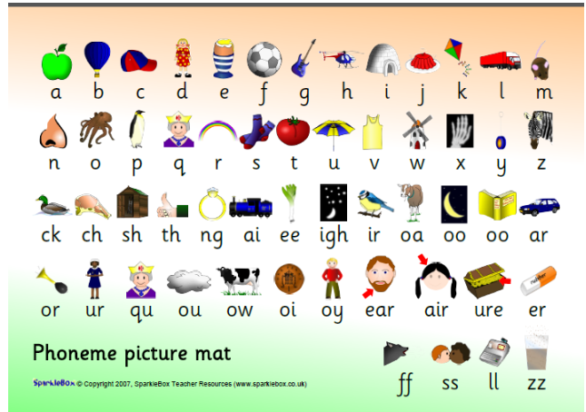
This picture mat is used regularly in Year 3 to revise the phoneme sounds. The picture reminds the children of the sound and how to pronounce it. Practising these regularly with struggling readers will help icnrease confidence.
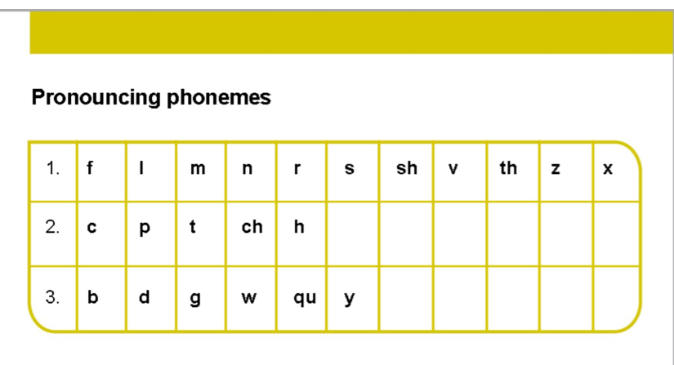
We encourage children to pronounce the phonemes in line 1 by continuing them fffff, lllllll, mmmmm, rrrr, ssss, vvv. Line 2 is quieter – without using their voice EG p / h by panting like a dog. Line 3 is more difficult – the sounds should be as clean and clear as possible.

How does this help with reading?
If children come across new words in their reading we encourage them to use their phoneme sounds and letter knowledge to ‘sound it out’ and decipher how to read the word. This is when their phonics is applied. The longer the word, the trickier this is, but if your child is confident in their phonics this will help. If your child is struggling, breaking the word down together and looking at it in chunks can help. Sometimes writing the word out or covering sections of the word will also help. Make sure you also talk about what the word means – as well as reading its context within the sentence/paragraph.
READING

“Parental involvement in their child’s reading has been found to be the most important determinant of language and emergent literacy.”
Parents are a child’s first educator and have the greatest influence on their child’s educational development.
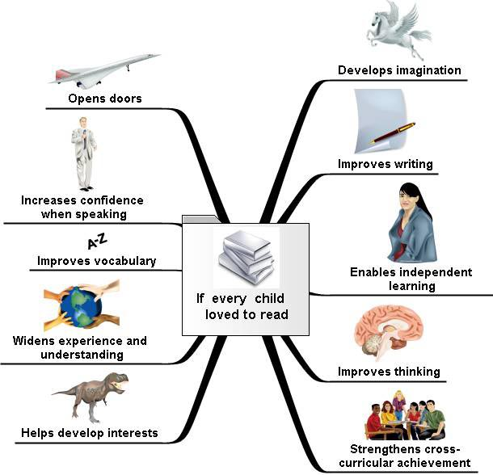
What do we want for our children as readers?
- To read for pleasure
- To be able to choose what they would like to read for themselves
- To be able to summarise what has been read
- To read with understanding
- To read with expression
- To have reasons for preferences in what they read

How can we achieve this?
- Read yourself
- Point out the words all around you
- Take an interest and be positive
- Make the story come to life
- Discuss books
- Emphasise it is not just books
- Set a good example
- Read a variety of materials
- Make reading fun!

How can I be involved in my child’s reading?
- Encourage independent reading but remember - children will still enjoy reading to / with you.
- Help your child to read with expression so the story comes to life. This will help them read more fluently.
- Don't worry if your child reads newspapers, magazines, comics and the internet as well as books.
- Discuss reading. Ask your son or daughter about what's interested them in anything they've read recently
- Read yourself. Set a good example by reading for pleasure and talking about the reading you do at work and home.
- Read as a pair
- Listen to your child read a variety of texts
- Discuss what they are reading and what you are reading

READING AND COMPREHENSION
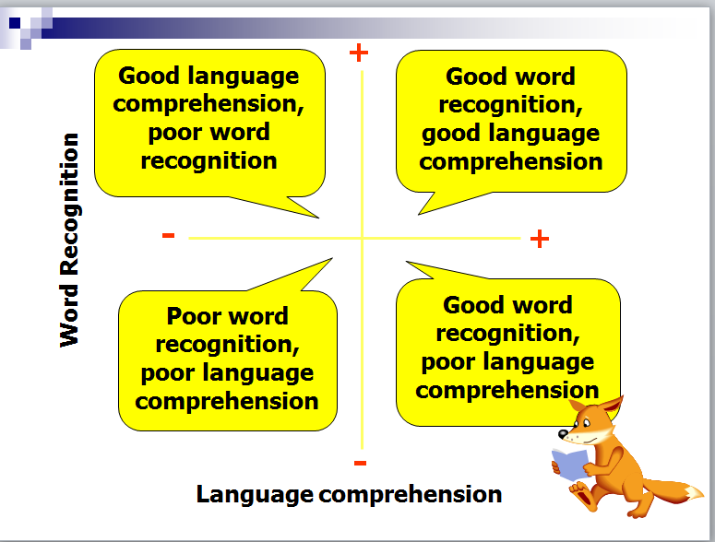
Reading is not just about being able to recognise words. Sometime a fluent reader can have little understanding of what they are reading. This is why the discussion element of reading with your child is essential. It’s here that you can probe their understanding and ensure they comprehend what they are reading.

What if they can’t answer the question?
Give them a helpful starting point:
“Well, I think………….”
“Here are a couple of ideas – which one do you think is the best?”
“Which of the words in this phrase really tells me how the character is feeling?”
“Yes, I agree – and it could also be because……..
Seeing you being involved in their reading and the discussion is always a positive and encouraging experience for even the most reluctant readers.

QUESTIONING TECHNIQUES

Types of questions

There are three types of questions that we use with the children when discussing what they have read.

Literal (retrieval) questions

This is where the answer is actually written in the text. (Eg – tell me, describe, what does Bob say, who, when, where, what? Etc)

Inferential questions
This is where the answer is not written in the text, but there is a clue that will help the children work it out. (Eg – explain, apply, select, change, arrange, order, why? How?)

Deduction or speculative questions
This is when there are no clues given in the text. Children need to say what they think, giving an opinion or a reason based on what has been read as well as prior knowledge of feelings or emotions. These are much harder questions and often require a deeper level of thinking. Sometimes children may want to find examples in the text to back up what they are saying. (Eg – what if? Why? Compare? What do you think? What if...?)

Questions to use
The questions in this leaflet are given as a guide. They can be used to create discussion points when reading with your child, or a few questions can be selected and answered each time you read with your child. Checking your child’s understanding of what they have read is just as important as developing their skills as a reader.
QUESTIONS

Understanding, describing and retrieving information
· Where did the story take place?
· When did the story take place?
· What did he/she look like?
· Where did he/she live?
· Who are the characters?
· What happened in the story?
· What kinds of people are in the story?
· Find the part that tells me….
Deducing, inferring and interpreting
· What makes you think that?
· What words give you the idea that….? Why?
· How do you feel about….? Why?
· Can you explain why….?
· If you were going to interview the author, what questions would you ask?
· What sort of person would you recommend this book to?
· What do you think about….?
· At the end of the story, the main character is feeling….? Does this surprise you?
· What do you think….. is thinking/feeling, when ….. happened?
· What was your favourite part? Why?
· What do you think might happen next? Why?
· How did …. change during the story?

Identifying and commenting on the structure of the text
· Were you surprised by the ending?
· How would you change the ending?
· How were the beginning/ending similar/different?
· What would happen if the order of events was changed?
· How do the pictures add to the story?
· How do the chapters help the story?
Explaining and commenting on the use of language
· Why did the writer choose to use these words?
· How has the author used adjectives to help the story?
· What do the physical descriptions of the characters tell us about their feelings?
· What does the word …. tell us about ….?
· Why do you think the author chose this word/title/heading?
Identifying and commenting on the purpose of the writing
· Can you think of another story that is similar? How? Why?
· Why do you think the author chose this setting?
· What effect did this story have on you as a reader?
· What was the most exciting part of the story? Why?
Relating texts to individual experiences
· Can you think of another story that is similar? How? Why?
· Why do you think the author chose this setting?
· What effect did this story have on you as a reader?
· What was the most exciting part of the story? Why?
· What do you think would have happened if…?
· Does this story remind you of any personal experiences? Describe.
· Have you ever been in a similar situation? What happened?
General opinions
· Did you like the story? Why/why not? What would you change?
General Discussion
Look at and discuss the front cover/blurb. What do you think this is about? Why? What clues can you see/read? Have you read anything by this author before? What do you think the characters might be like? Why?

Term | Definition
Active voice | Most verbs in any text are expressed in the active voice. It is easily recognised since the subject and ‘do-er’ or ‘be-er’ of the action are the same, e.g.  - The girl closed the door.  - The kitten unravelled the ball of wool.  - Tom has smashed the pane of glass.
Adjective | An adjective can describe or modify a noun or pronoun. As some other word classes can also perform these functions, it is helpful to identify adjectives by the way in which they can be used, e.g.  - Before a noun – the beautiful ballerina; what a heroic act; the stormy, restless sea.  - After a verb to complete the meaning of a clause – this is important; the cat looked grumpy; it seemed very strange.  Many adjectives also have a comparative and superlative form, e.g. I am taller than my sister; I am the tallest in my family; these shoes are more comfortable; these are the most comfortable shoes.
Adverb | An adverb can describe or modify the meaning of words other than nouns. Many adverbs are related to adjectives and in standard English consist of the adjective with -ly added. It commonly indicates:  - manner (how something happens), e.g. she waited patiently; slowly, they emerged; he performed well in the match  - time (when something happens), e.g. yesterday, it rained; he has already left; the bus arrived early  - frequency (how often something happens), e.g. occasionally, I make mistakes; he is usually at home  - place (where something happens), e.g. how will you travel there?; we are going abroad; they hid upstairs  - degree (to what extent something happens), e.g. it was entirely her fault; we hardly noticed; they were very polite  - causation (why something happens), e.g. so we stayed at home; nevertheless, we had a good time
Adverbial | An adverbial is any word, phrase or clause that functions like an adverb. An adverbial may contain an adverb but it does not have to; it may be a preposition phrase or a subordinate clause, e.g.  - We should look in here. (adverb)  - They fell asleep during the film. (preposition phrase)  - He woke as the sun began to rise. (subordinate clause)  An adverbial can be placed at the beginning, middle or end of a clause, e.g.  - At the railway station, I waited for my train to Manchester.  - I waited at the railway station for my train to Manchester.  - I waited for my train to Manchester at the railway station.  Since an adverbial’s usual position is at the end of a sentence, it is described as ‘fronted’ when at the front and ‘embedded’ when it is in the middle.
Alliteration | A phrase where adjacent or closely connected words begin with  the same phoneme (sound/letter) eg several silent, slithering  snakes
Antonym | Two words are antonyms if their meanings are opposites.
Apostrophe | A punctuation mark indicating:  Contraction: two words shortened into one eg do not = don’t, can  not= can’t  Possession: Applied to all possessives marked by s, except its. Eg  the girl’s frock (belonging to the girl)
Article | English has two articles:  - the is the definite article. It is used to indicate that the person, place or thing can be identified by the hearer or reader, e.g. Put it on the wooden table.  - The blue parrot flew overhead.  - We listened to the orchestra.  - a (or an before a vowel sound and sometimes before an ‘h’) is the indefinite article. It indicates that the person, place or thing cannot be identified by the hearer or reader, e.g. Put it on a wooden table.  - A blue parrot flew overhead.  - We listened to an orchestra.
Audience | The people addressed by the text. The term refers to listeners,  readers of books and film/TV audiences
Autobiography | life story of an individual written by the person.
Auxiliary Verb | See Verb
Ballad A poem or story which tells a story. | Ballad A poem or story which tells a story.
Biography A life story of an individual written by another author. | Biography A life story of an individual written by another author.
Character An individual in a story or play or poem whose personality can be | Character An individual in a story or play or poem whose personality can be
Clause | A clause is a group of words built around a verb. Sentences are made up of one or more clauses.  A main clause contains a finite verb. It can form a sentence on its own and therefore is sometimes referred to as an independent clause, e.g.  - He put on his coat.  A subordinate clause is dependent for its meaning on the main clause and is therefore sometimes referred to as a dependent clause. It cannot stand alone as, without the main clause, its meaning is unclear, e.g.  - He put on his coat because it was cold.  Subordinate clauses can be classified as:  - relative clauses, e.g. the book that I was reading.  - adverb clauses, e.g. He put on his coat because it was cold.  - noun clauses, e.g. I know that it’s raining.  Clauses can be finite or non-finite depending on the verb form used, e.g.  - They went to the beach when it stopped raining. (clause using a finite verb)  - Looking out of the window, he waved to the postman. (clause using a non-finite verb)  - She had to work hard to achieve her goal. (clause using a non-finite verb)  - Reassured by his coach, he resumed his training programme. (clause using a non-finite verb)  Most subordinate clauses can be fronted (placed at the front of the main clause in a sentence), embedded (placed in the middle of the main clause in a sentence) or placed at the end of the main clause in a sentence.
Cohesive device | A cohesive device is a word or grammatical structure that signals a link between ideas within and across clauses, sentences and paragraphs. Connectives, pronouns, vocabulary choices and punctuation can all support textual cohesion.  - I always save my pocket money whereas my brother spends his straightaway.  - John enjoys school; he is particularly good at art.  - We had good weather on holiday last week. It was sunny for three days although it was slightly cooler on Thursday. However, it warmed up again towards the end of our stay.  In longer pieces of text, cohesion is aided by backward and forward references, typically through the use of pronouns, deliberate repetition and synonyms. This is sometimes called a reference chain.
Colon | A punctuation mark used to introduce: a list, a quotation or a  second clause which expands or illustrates the first: he was very  cold: the temperature was below zero.
Comma | Punctuation mark marking the relationship between parts of a  sentence, or used to separate items in a list.
Complex verb phrase | A complex verb phrase consists of a lexical verb and one or more auxiliary verbs, e.g.  - He was running.  - He has been running.  - He should have been running.
Compound Word | A word made up of two other words: football, headrest.
Comprehension | The level of understanding a text.
Connective or conjunction | A connective is a general term for words that link ideas together, e.g.  - although, but, on the other hand.  Connectives often act as cohesive devices to support text coherence.  There are different types of connectives that perform different functions, e.g.  - Coordinating connectives join words, phrases or clauses that are equal. The main coordinating connectives are and, or, but.  - Subordinating connectives introduce a subordinate clause, e.g. because, although, unless.  - Temporal connectives signal time or chronology, e.g. next, first, later, meanwhile.  - Causal connectives signal cause and effect, e.g. because, therefore, consequently, so.
Contraction | A contraction is a shortened or simplified form of a word attached to the preceding word. Verbs in their contracted form use an apostrophe in place of any omitted letters. This is often referred to as an apostrophe for omission and is more typically found in informal writing, e.g.  - I’m so excited. (I am)  - They’ve decided to go by train. (They have)  - He’d love to come too. (He would)  - We’re off to the beach. (We are)  - It’s a fabulous day. (It is)  - Who’s got the picnic? (Who has)  - I would’ve come but I have to cook dinner. (would have)  - She’ll catch you up later. (She will)  - Sam’ll catch the ball. (Sam will)
Demarcation | Some forms of punctuation are used to indicate (or demarcate) sentence boundaries. These are:  - full stops  - question marks  - exclamation marks  - ellipses  A capital letter is always used to indicate the start of a sentence. A comma should never be used to demarcate a sentence boundary; when it is used in this way it is often referred to as a comma splice and is considered an error, e.g.  - I told him to go, he didn’t listen. (incorrect)  - I told him to go. He didn’t listen. (correct)
Dialogue | A conversation between two parties, may be spoken or written.
Discussion Text | A text which represents all sides of an issue.
Draft | Preliminary written form of a document.
Edit. | To modify/change either own or another’s work.
Ellipsis . . . | This signifies a place where something has been omitted, or there is a pause or interruption. The dots which mark this are called ellipsis.
Empathy | Identifying with another, the ability to see situations from the
Exclamation Mark | Punctuation mark used at the end of a sentence to indicate great
Explanation Text | Text written to explain a process or answer a question.
Fable | short story which is devised and written to convey a useful  moral issue. Animals are often used as characters.
Fiction | Text which is invented by a writer of speaker.
Finite and non-finite | The finite inflections of a verb express a choice of tense and person, e.g.  - She walks to school every day.  - They ran down the road.  - The clowns tumbled and juggled and the crowd roared with laughter.  The non-finite inflections of a verb do not express these choices. There are three non-finite forms:  - The present participle (-ing), e.g. breathing heavily, we ran up the stairs; scowling fiercely, she opened the window and shouted.  - The past participle (-ed), e.g. exhausted by the climb, the hikers decided to rest; terrified, the children hid behind the curtain.  - The infinitive (to -), e.g. we wanted to arrive early; to function properly, the power must be switched on.
Fronted adverbial | See adverbial
Genre | Refers to different types of writing.
Grapheme | Written representation of a sound, may consists of one or more  letters.
Homograph | Word with same spelling as another, but different meaning eg a  lead pencil/the dog’s lead.
Homophone | Words which sound the same but have different meaning or  spelling eg right/write/rite.
Hyphen | A punctuation mark which links two words or parts of words.
I and me | According to standard English:  - I is used on its own or with a noun when either is the subject of the verb: I went for a walk.  - Jane and I went for a walk.  - Me is used on its own or with a noun when either is the object of the verb: The teacher blamed me.  - The teacher blamed Jane and me.  - Me is also used when the pronoun is the object of a preposition: Jane came cycling with me.
Imperative | An imperative is a verb form that expresses a directive or a command. The verb is used in its base form, typically without a subject, e.g. Sit down; Come here; Put the glass in the basin.
Impersonal construction | An impersonal construction is one without an agent or where the agent has been replaced with the impersonal ‘dummy’ pronoun ‘it’:  - Politeness is expected at school. (without an agent)  - Visiting museums will expand children’s knowledge. (without an agent)  - It may be wise to take an umbrella. (impersonal dummy pronoun it)  An impersonal style often uses impersonal constructions, as well as, for example, nominalisation and the passive voice to achieve a more formal register.
Inflection | An inflection is an adaptation of a verb or noun, typically used to form a correct grammatical relationship within a sentence – it is used to indicate tense, mood, number, person, gender, e.g.  - have/had, taking/taken, do/did, speak/spoke (tense)  - woman/women, horse/horses (number)
Internal sentence  punctuation | A range of punctuation can be used within sentences to clarify  meaning, e.g.  • colons to introduce a list  • commas to separate items in a list and to mark phrases or  clauses  • semi-colons to mark heavier boundaries between main  clauses, or to separate words or phrases in a complex list  • apostrophes to indicate contracted forms or possession  • inverted commas to indicate direct speech  • ellipsis to indicate omitted words or for dramatic or  rhetorical effect  • brackets, dashes or commas to indicate parenthesis
Lexical verb | See verb.
Metaphor | Where the writer writes about something as if it were really  something else.
Modal verb | See verb.
Modelling | Refers to demonstration of an aspect of reading or writing a  teacher or adult support.
Myth | An ancient traditional story of gods or heroes which address a  problem or concern human existence.
Narrative Text | Text which re-tells events.
Nominalisation | Nominalisation is the process of turning words from other word classes into nouns e.g.  - the charity walk  The verb ‘to walk’ has been nominalised to the noun ‘walk’.  A word that can function as both a noun and a verb (in its present participle form) is also sometimes known as a gerund, e.g. painting, barking.  Nominalisation is often used in more formal writing, which calls for an impersonal, academic style.
Non-chronological | Organised without reference to time sequence.
Non-standard English | Non-standard English is a variety of English that incorporates the linguistic features of a specific local dialect. It is not generally used in formal speech and writing, except in informal dialogue. It may be linked to a region, but can be spoken with any accent.
Noun | A noun is often defined as the name given to a person, place or thing. Typically, these are physical entities that can be seen, touched, smelt, tasted or heard.  There are different groups of nouns, e.g.  - A proper noun is the name of a specific person, place or thing, e.g. Snow White, France, Wednesday. It always begins with a capital letter no matter where it occurs in a sentence.  - A common noun identifies a person, place or thing more generically, e.g. children, restaurant, apple.  Nouns may also be classified as concrete, abstract or collective:  - A concrete noun refers to objects that exist physically, e.g. clock, pens, dog.  - An abstract noun names a thing such as a feeling, quality or concept that has no physical form, e.g. sorrow, courage, freedom.  - A collective noun refers to a group
Noun phrase | A noun phrase typically consists of a noun that is modified by other words such as articles, adjectives, additional nouns or preposition phrases, e.g.  - The shed  - The blue shed  - The blue garden shed  - The blue garden shed behind the rose bushes
Object | The object is a noun that refers to a person or thing, other than the subject, which is involved in or affected by the action of a verb. The verb’s object normally follows it, e.g.  - He ate the tomato.  - We liked her.
Onomatopaeia | Words which echo sounds associated with meaning eg clang, hiss,  and crash.
Pargraph | A section or piece of writing.
Passive voice | Verbs expressed in the passive voice (unlike the more common active voice alternative) transform the active object into the subject.  The subject is the recipient (rather than the agent) of the action, e.g.  - The door was closed by the girl.  - The ball of wool was unravelled by the kitten.  - The pane of glass has been smashed by Lisa.  The verb ‘to be’ is followed by the past participle (see verb) form of the verb, e.g.  - The door was closed by the girl.  - The ball of wool was unravelled by the kitten.  - The pane of glass has been smashed by Lisa.  The ‘by’ phrase indicates the active subject. Its use is optional (omission is sometimes desirable if the intention is to hide the person responsible for the action), e.g.  - The door was closed.  - The ball of wool was unravelled.  - The pane of glass has been smashed.
Personification | A form or metaphor in which language relating to human action eg  the weather is smiling on us today.
Phoneme | The smallest unit of sound in a word.
Phrase | A phrase is a group of words that are grammatically connected. Phrases are classified according to the word they expand, e.g.  - noun phrase – the blue garden shed  - preposition phrase – through the window  - complex verb phrase – has been working
Plural | See Singular and Plural
Prefix | A prefix is a letter or string of letters which is added to the beginning of a root word in order to modify or change its meaning, e.g.  - appear / disappear  - take / retake / undertake
Preposition | A preposition indicates a relationship, often in time or space, between nouns or noun phrases and other parts of the clause, e.g. across, in, at, under, with, of.  A preposition typically introduces a preposition phrase, e.g.  - The woman in the red dress was playing the piano.  - The blue garden shed behind the rose bushes was empty.  Preposition phrases usually modify verbs (as adverbials) or nouns, e.g.  - The bowl of fruit stood on the table. (adverbial)  - Collect the parcel from the house over the road. (adverbial)  - Collect the parcel from the house over the road. (noun modifier)  - Since auditioning for the play, she has grown in confidence. (adverbial, introducing a non-finite clause)  - He put down his pen after the teacher told him to stop writing.  - (subordinating connective)
Pronoun | A pronoun is a word that can act as a substitute for a noun or noun phrase. Pronouns can be used in a text to avoid repetition and as points of reference to strengthen cohesion. Unlike a noun, it is difficult to modify a pronoun, e.g.  - ‘A sparkling river’ cannot become ‘A sparkling it’.  - ‘The boy next door’ cannot become ‘The he next door’.  For the level 6 test, children need to be aware that there are different types of pronoun, e.g.  Personal pronouns indicate person, number and gender, e.g. I, me, you, she, her, he, him, it, we, us, they, them.  Relative pronouns introduce a relative clause, e.g. who, whom, whose, which, that.  - I enjoy my swimming, which keeps me fit.  - The girl who won the race was very fit.  Possessive pronouns express ownership, e.g. mine, yours, his, hers, its, ours, yours, theirs, one’s.  These can be used on their own, e.g.  - Mine is the red and white one.  - The blue one might be theirs.  There are also possessive determiners (sometimes confused with possessive pronouns), which are easily identifiable since they must be followed by the noun to which are they linked, e.g.  - Look in her book.  - Our favourite meal is pasta.  Interrogative pronouns introduce questions, e.g. who, when, how.  - Who did it?  - What are you doing?
Question Mark | Punctuation mark used at the end of a sentence to denote a  question.
Recount Text | A text written to retell.
Report Text | A non chronological text written to describe or classify.
Relative Clause | A relative clause is a type of subordinate clause that makes the meaning of the noun more specific. It is introduced by a relative pronoun (who, whom, whose, which, that).  There are two types of relative clause: non-defining (or non-restrictive) clauses and defining (or restrictive) clauses.  - My brother, who lives in France, drives a blue van. (Non-defining – the fact that my brother lives in France is simply additional information.)  - My brother who lives in France drives a blue van. (Defining – relating specifically
Rhetorical Device | A rhetorical device is associated with language intended to persuade or  impress, typically in order to create a particular effect on the reader or  audience. A commonly used rhetorical device is a rhetorical question,  which is posed for deliberate effect and does not require an answer.  • Why do I bother?  • Will you ever remember to hang up your coat?  • Who needs to know about that?
Roots of words of Derivations | A root word is the part of the word that contains its original meaning. Derivation is the process by which new words are formed from a root word to give related words different meanings and/or to show that they belong to different word classes. It is achieved by changing the shape of the root word or base, e.g. song from sing, or by adding a prefix or suffix, e.g. discovery, uncover, recover from cover. Many words are derived from Greek or Latin roots, e.g. bio for life in biography, biology, autobiography.
Semi-colon | A punctuation mark used to separate phrases or clauses in a  sentence.
Sentence | A sentence consists of a group of words that work together to create meaning, and that are grammatically separate from neighbouring sentences. A sentence typically consists of clauses, including at least one main clause. It is demarcated by a capital letter at the start and by some form of end punctuation, e.g. full stop, question mark, exclamation mark or ellipsis.  There are different types of sentences:  - A statement gives information and normally has the subject before the verb, e.g. It rained heavily on Wednesday night.  - A question normally asks for information and is signalled grammatically by: its subject following an auxiliary verb, e.g. Are you ready?  - an interrogative pronoun, e.g. What happened?  - A command is a sentence that directs someone or something to do something. It uses the imperative form of the verb, e.g. Turn that radio off now.  Sentences can have different grammatical structures:  - A single-clause sentence consists of a single main clause, e.g. The dog barked.  - Jake won the egg and spoon race.  - The teacher with the shiny red sports car drove slowly out of the school car park on the last day of term.  - A multi-clause sentence consists of at least one main clause and any number of subordinate clauses, e.g. While we were playing tennis, I tripped and sprained my ankle.  - Ron cycled down the hill; he didn’t see the pothole in the road.
Simile | The writer creates an image in readers minds by comparing a  subject to something else eg as strong as an ox.
Singular and Plural | Most nouns have a singular and a plural form, signalling the difference between ‘one’ or ‘more than one’ person, thing etc. Many nouns can be changed to their plural form by adding an -s ending, e.g.  - bird / birds  - lily / lilies  Some nouns have an irregular plural form:  - foot / feet  - louse / lice  - leaf / leaves  Some nouns have the same form whether singular or plural:  - one sheep / several sheep  - one species / several species
Standard English | This is the variety of the English language that is generally used for formal purposes in speech and writing. It is not the English of any particular region and it can be spoken with any accent.
Subject | The subject is the noun, pronoun or noun phrase that stands before a verb, and which is involved in subject-verb agreement. It normally expresses the ‘do-er’ or ‘be-er’ of the verb, e.g.  - We were going shopping.  - Zak is tired.
Subject-Verb agreement | If the verb is in the present tense, it agrees (in standard English) with the subject, e.g.  - she plays (not she play)  - they play (not they plays)  In the past tense, subject-verb agreement is only found in the verb ‘to be’, e.g.  - She was playing / they are playing  - I laughed / the girls laughed
Suffix | A suffix is a letter or string of letters that is added to the end of a root word in order to modify or change its meaning. Suffixes are used in inflections (e.g. walked, birds) and also in deriving new words, often with a change of word class, e.g.  - teach / teacher (changes verb into noun)  - terror / terrorise (changes noun into verb)  - beauty / beautiful (changes noun into adjective)
Synonym | Two words are synonyms if they have the same meaning or similar meanings, e.g. pointed may be synonymous with sharp, tapered, jagged or with cutting, biting, caustic, depending on context.
Syntax | The grammatical rules that determine the arrangement of words in  phrases, clauses and sentences are known as syntax.
Tense | Tense indicates the relationship between the form of a verb and the time reference of the action, event or process it expresses, e.g.  - They ran down the road. (past tense)  - She walks to school most days. (present tense)
Tense Agreement | Tense agreement means consistency of tense, e.g.  • They ran down the road and bought an ice cream.  • She walks to school most days but catches the bus every Friday.
Verb | A verb is a word that can be inflected for tense and expresses an action, an event, a process, a sensation or a state of being, e.g.  - They crossed the river.  - The bell rang loudly.  - The staff made a decision.  - He worried about his homework.  - I am very good at mathematics.  There are three main types of verb:  - Lexical verbs are sometimes referred to as ‘main’, ‘full’ or ‘content’ verbs. They are not dependent for their meaning on other verbs, e.g. speak, accept, discover.  - Auxiliary verbs (be, do, have) are sometimes referred to as ‘helping’ verbs because they can assist, modify or refine another verb.  - Modal verbs are a type of auxiliary verb that expresses degrees of possibility, probability and certainty. The core modal verbs are: can, could, may, might, shall, should, will, would, must.
Verb Inflection | Most verbs can occur in different inflections:  - The infinitive has no tense and is often preceded by to, e.g. to appear, to sign.  - The present plural looks like the infinitive except in the verb ‘to be’, e.g. they are, they sign.  - The present singular is normally formed by adding -s to the base form, e.g. Claire grabs the ball and shoots at the goal (but: Ali is tall and has brown eyes).  - The past tense is normally formed by adding -ed to the base form (e.g. We played hockey) but many common verbs have irregular forms (e.g. I caught several fish and I was happy).  - The past participle (see finite and non-finite) normally has the same form as the past tense (e.g. I have finished; the form was signed by the headteacher); but in many common irregular verbs it is different (e.g. We have been away, and our milk was stolen).  - The present participle is always formed by adding -ing to the base form, e.g. He was being naughty. He was caught stealing. Anyone making a noise will be punished.
Word Class | The term ‘word class’ refers to a group of words that can perform a similar function, e.g. nouns, pronouns, adjectives, verbs, adverbs, prepositions. Some words can belong to more than one class, depending on the context in which they are used, e.g.  - I hope to sail round the world next year. (verb)  - My boat has a blue sail. (noun)
Word Families | Word families consist of groups of words that share a common root,  e.g. act, action, react, reaction, activate.

