

Queen Eleanor’s CofE Junior School

Phonics at Home
A Guide For Parents

LANGUAGE SKILLS - PHONICS
Phonics refers to a method for teaching speakers of English to read and write their language. It involves connecting the sounds of spoken English with letters or groups of letters (e.g that the sound /k/ can be represented by c, k, ck or ch spellings) and teaching them to blend the sounds of letters together to produce approximate pronunciations of unknown words. In this way, phonics enables people to use individual sounds to construct words. For example, when taught the sounds for the letters t, p, a and s, one can build up the words "tap", "pat", "pats", "taps" and "sat"
How is phonics taught?
A lot of phonics is taught throughout Infant School, however this is reinforced and some areas revisited as needed throughout KS2. In order to support this at home, here are some of the methods followed:
Synthetic phonics - an approach associated with the teaching of reading in which phonemes (sounds) associated with particular graphemes (letters) are pronounced in isolation and blended together (synthesised). For example, children are taught to take a single-syllable word such as cat apart into its three letters, pronounce a phoneme for each letter in turn /k, æ, t/, and blend the phonemes together to form a word.
Analytical phonics - an approach associated with the teaching of reading in which the phonemes associated with particular graphemes are not pronounced in isolation. Children identify (analyse) the common phoneme in a set of words in which each word contains the phoneme under study. For example, teacher and pupils discuss how the following words are alike: pat, park, push and pen.
Analogy phonics - a type of analytic phonics in which children analyse phonic elements according to the phonograms in the word. A phonogram, known in linguistics as a rime, is composed of the vowel and all the sounds that follow it, such as –ake in the word cake. Children use these phonograms to learn about “word families” for example cake, make, bake, fake.
Embedded phonics - an approach to the teaching of reading in which phonics forms one part of a whole language programme. Embedded phonics differs from other methods in that the instruction is always in the context of literature rather than in separate lessons, and the skills to be taught are identified opportunistically rather than systematically.
But I don’t understand the vocabulary of phonics!
Don’t worry – your children should be able to explain these terms. If not, here is a quick glossary of the most important phonics words and their meanings.
blend (vb) — to draw individual sounds together to pronounce a word, e.g. s-n-a-p, blended together, reads snap
cluster — two (or three) letters making two (or three) sounds, e.g. the first three letters of 'straight' are a consonant cluster
digraph — two letters making one sound, e.g. sh, ch, th, ph.
vowel digraphs comprise of two vowels which, together, make one sound, e.g. ai, oo, ow
split digraph — two letters, split, making one sound, e.g. a-e as in make or i-e in site
grapheme — a letter or a group of letters representing one sound, e.g. sh, ch, igh, ough (as in 'though')
grapheme-phoneme correspondence (GPC) — the relationship between sounds and the letters which represent those sounds; also known as 'letter-sound correspondences'
mnemonic — a device for memorising and recalling something, such as a snake shaped like the letter 'S'
oral blending - hearing a series of spoken sounds and merging them together to make a spoken word. For example, when a teacher calls out ‘b-u-s’, the children say ‘bus
phoneme — the smallest single identifiable sound, e.g. the letters 'sh' represent just one sound, but 'sp' represents two (/s/ and /p/)
segment (vb) — to split up a word into its individual phonemes in order to spell it, e.g. the word 'cat' has three phonemes: /c/, /a/, /t/
VC, CVC, CCVC — the abbreviations for vowel-consonant, consonant-vowel-consonant, consonant-consonant-vowel-consonant, which are used to describe the order of letters in words, e.g. am, ham, slam.

How can I help with phonics?

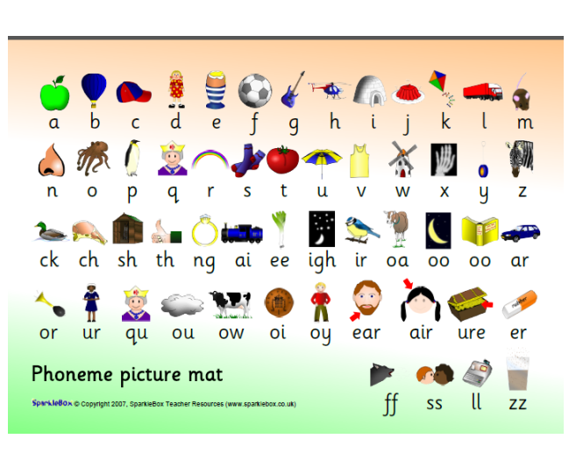
This picture mat is used regularly in Year 3 to revise the phoneme sounds. The picture reminds the children of the sound and how to pronounce it. Practising these regularly with struggling readers will help icnrease confidence.
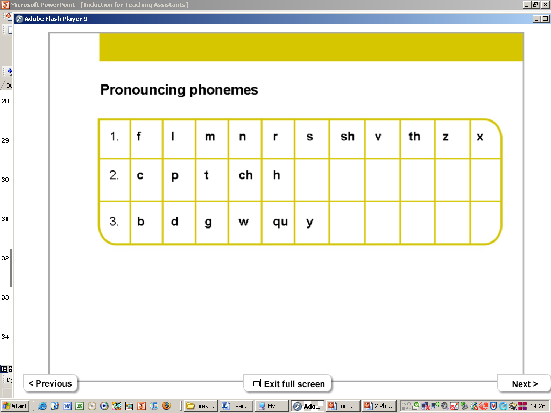
We encourage children to pronounce the phonemes in line 1 by continuing them fffff, lllllll, mmmmm, rrrr, ssss, vvv. Line 2 is quieter – without using their voice EG p / h by panting like a dog. Line 3 is more difficult – the sounds should be as clean and clear as possible.

How does this help with reading?
If children come across new words in their reading we encourage them to use their phoneme sounds and letter knowledge to ‘sound it out’ and decipher how to read the word. This is when their phonics is applied. The longer the word, the trickier this is, but if your child is confident in their phonics this will help. If your child is struggling, breaking the word down together and looking at it in chunks can help. Sometimes writing the word out or covering sections of the word will also help. Make sure you also talk about what the word means – as well as reading its context within the sentence/paragraph.

