

Queen Eleanor’s CofE Junior School

Reading at Home
A Guide For Parents

READING

“Parental involvement in their child’s reading has been found to be the most important determinant of language and emergent literacy.”
Parents are a child’s first educator and have the greatest influence on their child’s educational development.
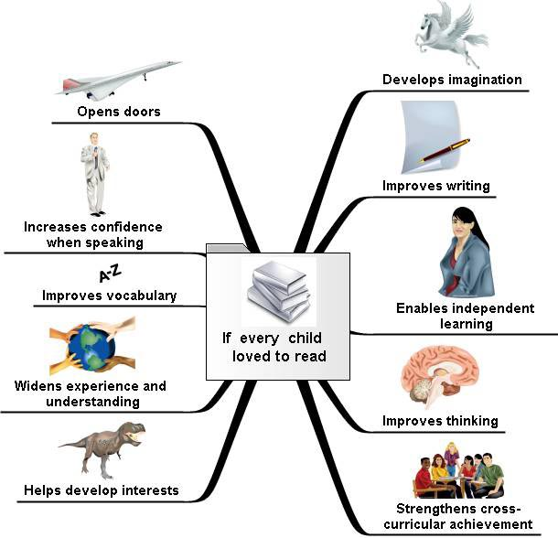
What do we want for our children as readers?
- To read for pleasure
- To be able to choose what they would like to read for themselves
- To be able to summarise what has been read
- To read with understanding
- To read with expression
- To have reasons for preferences in what they read

How can we achieve this?
- Read yourself
- Point out the words all around you
- Take an interest and be positive
- Make the story come to life
- Discuss books
- Emphasise it is not just books
- Set a good example
- Read a variety of materials
- Make reading fun!

How can I be involved in my child’s reading?
- Encourage independent reading but remember - children will still enjoy reading to / with you.
- Help your child to read with expression so the story comes to life. This will help them read more fluently.
- Don't worry if your child reads newspapers, magazines, comics and the internet as well as books.
- Discuss reading. Ask your son or daughter about what's interested them in anything they've read recently
- Read yourself. Set a good example by reading for pleasure and talking about the reading you do at work and home.
- Read as a pair
- Listen to your child read a variety of texts
- Discuss what they are reading and what you are reading

READING AND COMPREHENSION
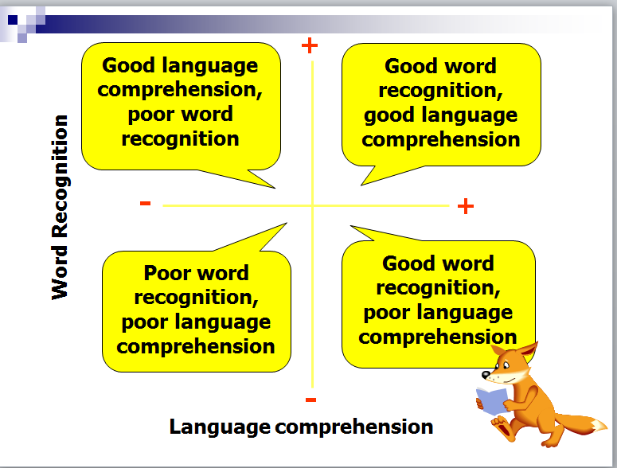
Reading is not just about being able to recognise words. Sometime a fluent reader can have little understanding of what they are reading. This is why the discussion element of reading with your child is essential. It’s here that you can probe their understanding and ensure they comprehend what they are reading.

What if they can’t answer the question?
Give them a helpful starting point:
“Well, I think………….”
“Here are a couple of ideas – which one do you think is the best?”
“Which of the words in this phrase really tells me how the character is feeling?”
“Yes, I agree – and it could also be because……..
Seeing you being involved in their reading and the discussion is always a positive and encouraging experience for even the most reluctant readers.

QUESTIONING TECHNIQUES

Types of questions

There are three types of questions that we use with the children when discussing what they have read.

Literal (retrieval) questions

This is where the answer is actually written in the text. (Eg – tell me, describe, what does Bob say, who, when, where, what? Etc)

Inferential questions
This is where the answer is not written in the text, but there is a clue that will help the children work it out. (Eg – explain, apply, select, change, arrange, order, why? How?)

Deduction or speculative questions
This is when there are no clues given in the text. Children need to say what they think, giving an opinion or a reason based on what has been read as well as prior knowledge of feelings or emotions. These are much harder questions and often require a deeper level of thinking. Sometimes children may want to find examples in the text to back up what they are saying. (Eg – what if? Why? Compare? What do you think? What if...?)

Questions to use
The questions in this leaflet are given as a guide. They can be used to create discussion points when reading with your child, or a few questions can be selected and answered each time you read with your child. Checking your child’s understanding of what they have read is just as important as developing their skills as a reader.
QUESTIONS

Understanding, describing and retrieving information
· Where did the story take place?
· When did the story take place?
· What did he/she look like?
· Where did he/she live?
· Who are the characters?
· What happened in the story?
· What kinds of people are in the story?
· Find the part that tells me….
Deducing, inferring and interpreting
· What makes you think that?
· What words give you the idea that….? Why?
· How do you feel about….? Why?
· Can you explain why….?
· If you were going to interview the author, what questions would you ask?
· What sort of person would you recommend this book to?
· What do you think about….?
· At the end of the story, the main character is feeling….? Does this surprise you?
· What do you think….. is thinking/feeling, when ….. happened?
· What was your favourite part? Why?
· What do you think might happen next? Why?
· How did …. change during the story?

Identifying and commenting on the structure of the text
· Were you surprised by the ending?
· How would you change the ending?
· How were the beginning/ending similar/different?
· What would happen if the order of events was changed?
· How do the pictures add to the story?
· How do the chapters help the story?
Explaining and commenting on the use of language
· Why did the writer choose to use these words?
· How has the author used adjectives to help the story?
· What do the physical descriptions of the characters tell us about their feelings?
· What does the word …. tell us about ….?
· Why do you think the author chose this word/title/heading?
Identifying and commenting on the purpose of the writing
· Can you think of another story that is similar? How? Why?
· Why do you think the author chose this setting?
· What effect did this story have on you as a reader?
· What was the most exciting part of the story? Why?
Relating texts to individual experiences
· Can you think of another story that is similar? How? Why?
· Why do you think the author chose this setting?
· What effect did this story have on you as a reader?
· What was the most exciting part of the story? Why?
· What do you think would have happened if…?
· Does this story remind you of any personal experiences? Describe.
· Have you ever been in a similar situation? What happened?
General opinions
· Did you like the story? Why/why not? What would you change?
General Discussion
Look at and discuss the front cover/blurb. What do you think this is about? Why? What clues can you see/read? Have you read anything by this author before? What do you think the characters might be like? Why?

