Young persons kit list!

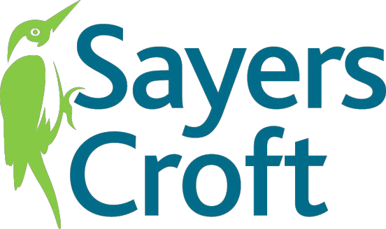

Sayers Croft will supply you with bedding, safety and educational equipment for your specific activities. Below is a general list of the kind of stuff you will need to think about bringing. Make sure you have your name on all things that belong to you and you can carry your bag as you will need to carry it to your chalet:

* **Lots of old clothes -** **you will definitely end up getting a bit mucky so don't bring anything too precious.**
* **Wash kit -** **including a towel, soap, toothbrush and toothpaste and brush/**

comb

* **At least two pairs of old trainers / boots (plus an additional pair if you are raft building)**
* **Wellies (but don't buy them especially as we can lend you some if you need them)**
* **Waterproofs (we can lend you these if needed) -** **and just because it's sum- mer doesn't mean it won't rain!**
* **Personal medication (including sunscreen if required)**
* **Indoor footwear**
* **Night clothes**
* **Hat (appropriate for the weather) and gloves (if cold)**
* **Teddy bear / soft toy**

The following things are extra stuff that you might need to consider bringing de- pending on what activities are included in your programme and the time of year you are visiting.

Swimming costume (summer only) Reading Book Small Rucksack Camera

Drinks Bottle Torch

Hair bands (if you have long hair)

You will be wearing a helmet for lots of the activities, please make sure your hair will easily fit underneath.

We do not allow chewing gum on site because of the mess it makes. Please do NOT bring aerosol sprays (deodorants and hairsprays) as they can set off our fire alarm.